Dear Customer,

As we move into Split's! 10th working year, we recognize the need to get the word out, and demonstrate the value Split! brings to our customers.
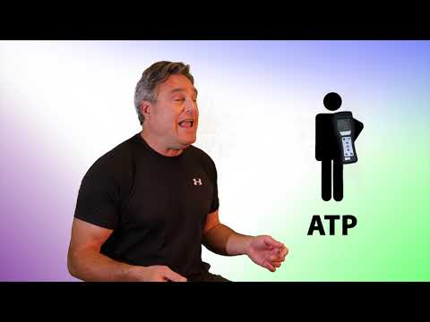
Split's! clearly defined differences are:
- Split! is a patented Non- Detergent cleaner.
- Split! will clean heavily soiled hard and soft floors and bring your hard floors and carpet
back to original.
- Split! will remove all the residue and soil that
was left behind from using detergent based cleaners.
- Split! will leave no residue.
- Split! will remove all ATP (Adenosine Triphosphate) while getting a reading of ZERO on an ATP meter.
- Split! requires no dwell time to remove all ATP.
- Split! is Green Seal Certified.
- Split! has professional tools for training your employees. Please go to the Split! website - https://www.splitcleaning.com/ We look forward to contacting you and setting up a time to demonstrate Split!
Sincerely,
Business Name
Account Representative
Location
Cell Number
Email Address

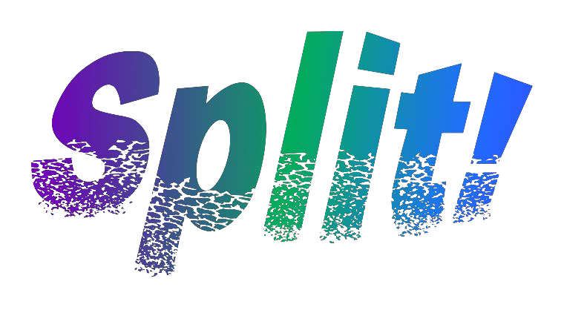
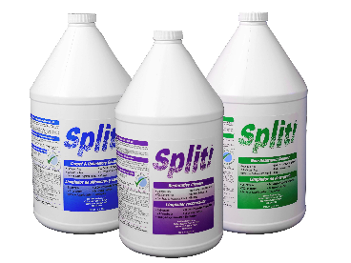
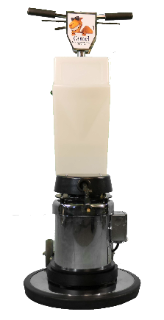
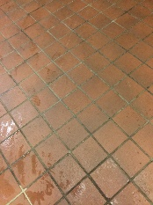
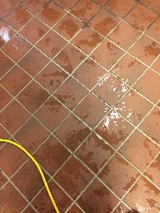
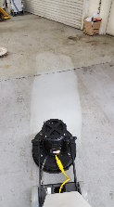
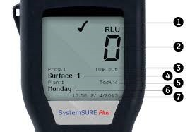
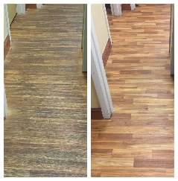
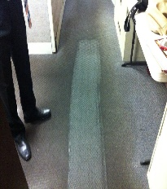
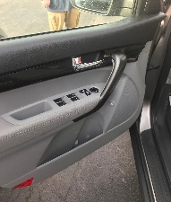
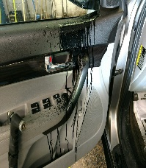
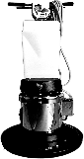
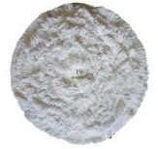
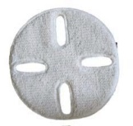
Before and After - Grouted Tile
One Pass
Split! Restorative Cleaner Before and After - Roofing Tar
Epoxy Floor Restoring
Before and After LVT Flooring

